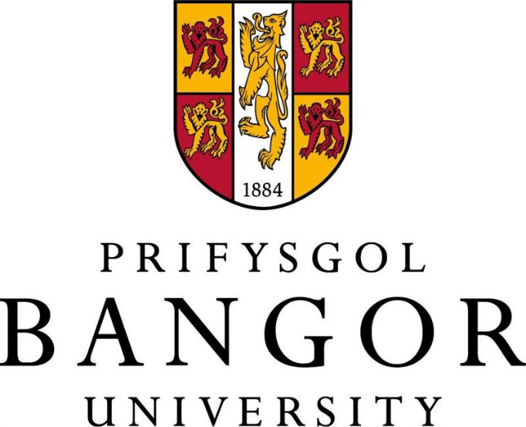

FLEXIBLE WORKING POLICY

Rev | Date | Purpose of Issue/Description of Change
1 | 2014 | Cosmetic changes
2 | 2015 | Update for clarity
3 | 2016 | Cosmetic changes
4 | 2018 | Review – no changes
5 | 2021 | Amendments to sections 5, 6 and 7 for clarity. Removal of 26 weeks service requirement.
6 | 2023 | Cosmetic changes and clarity to wording that does not affect content
Policy officer | Senior Responsible Officer | Approved By  and Date
Catherine Hughes | Steffan Griffiths | HRTG 21/04/2021

CONTENTS
- INTRODUCTION
- SCOPE
- MAKING AN APPLICATION
- EXAMPLES OF FLEXIBLE WORKING
- FLEXIBLE RETIREMENT
- TRIAL PERIODS
- REACHING A DECISION
- APPEALS
- POLICY REVIEW
1 INTRODUCTION
The University recognises that flexible working can provide benefits to both colleagues and the University and aims to support colleagues where possible to manage the balance between work and home life.
Managers are encouraged to facilitate requests unless they cannot be accommodated for business or operational reasons.
This policy applies to all colleagues of the University whether employed on a full-time, part-time, fixed term or permanent basis, applicable from day one of employment. It does not apply to agency workers or self-employed contractors
Colleagues are entitled to make up to two statutory flexible working requests in any rolling12-month period. 2 SCOPE
Arrangements may be requests which are temporary or permanent. A colleague does not have to explain how a flexible working change would affect Bangor University, nor do they have to explain how they will deal with the change.
The University recognises the positive impact of flexible working arrangements to:
- improve business efficiency and productivity;
- improve the balance between life and work;
- create a positive and inclusive environment;
The College/School /Department will consider all requests for flexible working on their own merits, and assessing each request based on the needs of both the business and the colleague.
It shall be the responsibility of both the Line Manager and the colleague to consider, assess and evaluate the potential business implications of implementing flexible working arrangements, for instance, but not limited to, the potential impact on costs, supervision, staff, services, and the University’s ability to meet its objectives.
It shall be the responsibility of both the Line Manager and the colleague to proactively manage flexible working arrangements, regularly reviewing existing flexible working arrangements (at least annually) to ensure that these continue to be effective in meeting the needs of both the University and the colleague.
Please note, flexible working will not be suitable for all roles at the University, for example colleagues who need to be on site to do their jobs, such as dedicated customer facing colleagues e.g. Security, Catering.
Should a colleague hold a Tier 2 / Skilled work visa, please consult the Human Resources Office at the earliest opportunity before submitting your request for flexible working in order to ensure it is permissible under your visa route – i.e, that you will not fall below the minimum salary requirements for your visa etc

3 MAKING AN APPLICATION
- Colleagues are encouraged to have an open conversation with their manager where they feel they may benefit from flexible working. All requests must then be made via the completion of the Flexible Working form in iTrent. Once submitted, this request will be formally considered by the Line Manager.
- Where necessary, the Line Manager should meet with the colleague, within 28 days of receiving the request, to discuss the details further. If the Line Manager has already decided to approve the formal request a meeting may not be needed.
- A decision on the flexible working request but be made by the Line Manager within two months.
- Once a decision has been reached, the Line Manager will complete the required sections of the form in iTrent before submitting to Human Resources for processing. Should the application be declined, the Line Manager must confirm the reasons why. The request can only be rejected under the business reasons as set out in legislation, as detailed below. Should the request be agreed, Human Resources will issue an Addendum of contract to confirm the revised work pattern, informing the payroll department of the change
- The Line Manager considers the request and confirms with HR by completing their part of the form within iTrent, whether they are unable to approve or approve the request. If unable to approve, the Line Manager must confirm the reasons why.
- HR formally contacts the employee with the outcome, issuing an addendum of contract where an application of flexible working is approved.

4 EXAMPLES OF FLEXIBLE WORKING

A range of flexible working practices and a variety of flexible working arrangements exist within the University. Flexible working can also be requested as a reasonable adjustment to help colleagues manage their health alongside work. For example, a disability, illness, or a life stage such as menopausal symptoms may require flexible working on a temporary or permanent basis. The types of flexible working detailed below are given as examples of flexible working that can be requested by colleagues, if mutually beneficial.
- A change from full-time to part-time working - Where an employee would like to decrease their hours of work. Please note, an increase in hours for those who hold a part-time contract of employment must be requested in iTrent by the Line Manager.
- Job sharing - This is a formal arrangement where two people voluntarily share duties and responsibilities of one full time post and the salary and benefits on a pro rata basis. Both colleagues take joint responsibility for the whole job
- Compressed hours - Compressed hours may be useful for colleagues who wish to continue to work current total hours and retain current benefits but would prefer to compress the hours into a shorter working week or fortnight, thereby allowing some ‘free time’ during the normal working week. An example is a ‘nine-day fortnight’ with 10 days' worth of hours worked over nine slightly longer days, allowing one day off per fortnight.

Dynamic Working
Dynamic working is not a right to work from home, but a framework to help colleagues work more flexibly where their job allows it. It is not the same as flexible working and there will be roles that do not lend themselves to dynamic working. Colleagues are reminded of the University’s Dynamic Working Policy and general adoption.

Career Break
A career break is an extended period of unpaid leave from work. The intention is that at some future date, the colleague will return to their substantive post. If a colleague is a member of a pension scheme, before taking the request any further, and at least six months before they wish to start the career break, they must discuss the situation with the University’s Pension’s Manager.

Working Outside the UK
Understandably, there are occasionally events in the lives of colleagues that prompt a request a period of living and working abroad (which is distinct from a request to change working pattern which is covered by this Flexible Working policy). Where colleagues make this request, they and their Line Manager will be required to follow the policy principles and process set out in the Policy for Staff Working Overseas.

5 FLEXIBLE RETIREMENT
Flexible retirement is a form of flexible working, and is where a colleague continues to work, but takes a reduction in salary, for example by working reduced hours, in exchange for payment of a portion of their pension. This mix of work and pension can offer an attractive way of tapering towards an eventual full retirement.

If colleagues are considering flexible retirement, they must:
- obtain further information about the pension scheme they belong to (USS / BUPAS / NEST) and its flexible / phased retirement provisions by visiting the Pensions website, and
- check they meet the eligibility criteria of their scheme.

Before taking their request any further, and at least six months before they wish to start your flexible retirement, they must:
- speak to their Line Manager about the proposed plans and seek their support, and
- contact the Pensions Manager and request a formal pension quotation on the basis of their proposed reduction in hours.

Please note, financial advice on pensions and other matters should be obtained from an Independent Financial Adviser. The University can only advise on options available and the procedure to be followed.

Should a colleague hold a work visa a change in hours or role may require a fresh application for a work visa to be made. Tier 2 / Skilled work visa holders who are considering flexible retirement must consult the Human Resources Office at the earliest opportunity.

Once colleagues have the information they need, and they wish to proceed they must complete the Flexible Working Application in iTrent. The Pensions Manager will progress the notification with the relevant pension scheme.

6 TRIAL PERIODS
Trial periods will be on the basis that they are short term, not normally extending beyond 12 months. The Line Manager will receive notification in advance of the trial period ending to ascertain whether the arrangement is to be confirmed on a permanent basis, extended for a further period of time, or whether the colleague is to revert to their previous working arrangements. Once confirmed, Human Resources will issue appropriate documentation to confirm the outcome and the Payroll department will also be informed.

7 REACHING A DECISION
If a Line Manager is unable to accommodate the request for flexible working, they must consult with the employee who made the request to discuss alternative arrangements.

A request for flexible working may only be declined on the basis of one or more of the following reasons:
- The burden of additional costs;
- Detrimental effect on the ability to meet customer demand;
- Inability to re-organise work amongst existing staff;
- Inability to recruit additional staff;
- Detrimental impact on quality;
- Detrimental impact on performance;
- Insufficiency of work during the periods they propose to work;
- Planned structural changes.

The ACAS guidelines(https://www.acas.org.uk/flexible-working) provide further information on the reasons that a refusal may be given under the current legislation.

8 APPEALS
In circumstances where a statutory request is refused or amended, the colleague will be informed of their right of appeal. An appeal should be made in writing to the Chief People Officer, stating the grounds of appeal, within 14 days of being informed of the decision.

The appeal must set out the grounds under which the colleague is making the appeal, and the correspondence must be dated.

The appeal will be considered by the Chief People Officer (or their nominee) and a nominated Director or Head of College / Department having no previous involvement in the case, having received the evidence in support of the appeal.

If the appeal is from a member of the Human Resources Department, the appeal will be considered by a Pro-Vice Chancellor (or their nominee) and a nominated Director or Dean of College. The appeal will be a desk top exercise where all the paperwork and processes followed will be considered.

The outcome of the appeal
If the appeal is upheld – the written decision will include a description of the colleague’s new working pattern and the date from which it will take effect.
If the appeal is dismissed – the written decision will state the grounds for the decision and will provide an explanation as to why the grounds for refusal apply in the circumstances. Employees are entitled to make two requests for flexible working per 12-month period, however, the employee must wait until 6 months have elapsed before making a request of the same kind that has been refused.

A written notice of the appeal outcome constitutes the University’s final decision and is effectively the end of the internal formal procedure.

9 POLICY REVIEW

This Policy and Procedure will be reviewed at regular intervals of not less than three years and will at all times be read and applied subject to the general law. All reviews will be undertaken in consultation with the recognised campus Trade Unions and any changes agreed with them, prior to approval from the University Council. This policy has been equality impact assessed prior to its implementation.

